# Topic : SE-UML rohit bisen

Que. 1- What is SDLC ?

Ans: Software development is an iterative process that is followed for a software project that consists of several phases for building and running software applications.

Que. 2 - Define Agile Model ?

Ans - Agile SDLC model is a combination of iterative and incremental process models with focus on process adaptability and customer satisfaction by rapid delivery of working software product. Agile Methods break the product into small incremental builds. These builds are provided in iterations. Each iteration typically lasts from about one to three weeks. Every iteration involves cross functional teams working simultaneously on various areas like −

Planning

Requirements Analysis

Design

Coding

Unit Testing and

Acceptance Testing.

Que. 3 - What is object oriented design ?

Ans: In the object-oriented design method, the system is viewed as a collection of objects (i.e., entities). The state is distributed among the objects, and each object handles its state data. For example, in a Library Automation Software, each library representative may be a separate object with its data and functions to operate on these data. The tasks defined for one purpose cannot refer or change data of other objects. Objects have their internal data which represent their state. Similar objects create a class. In other words, each object is a member of some class. Classes may inherit features from the superclass.

1 Objects: All entities involved in the solution design are known as objects. For example, person, banks, company, and users are considered as objects. Every entity has some attributes associated with it and has some methods to perform on the attributes.

2 Classes: A class is a generalized description of an object. An object is an instance of a class. A class defines all the attributes, which an object can have and methods, which represents the functionality of the object.

3 Messages: Objects communicate by message passing. Messages consist of the integrity of the target object, the name of the requested operation, and any other action needed to perform the function. Messages are often implemented as procedure or function calls.

4 Abstraction - In object-oriented design, complexity is handled using abstraction. Abstraction is the removal of the irrelevant and the amplification of the essentials.

5 Encapsulation: Encapsulation is also called an information hiding concept. The data and operations are linked to a single unit. Encapsulation not only bundles essential information of an object together but also restricts access to the data and methods from the outside world.

6 Inheritance: OOD allows similar classes to stack up in a hierarchical manner where the lower or sub-classes can import, implement, and re-use allowed variables and functions from their immediate superclasses.This property of OOD is called an inheritance. This makes it easier to define a specific class and to create generalized classes from specific ones.

7 Polymorphism: OOD languages provide a mechanism where methods performing similar tasks but vary in arguments, can be assigned the same name. This is known as polymorphism, which allows a single interface is performing functions for different types. Depending upon how the service is invoked, the respective portion of the code gets executed.

Que. 4 - What are uml diagrams?

Ans: We prepare UML diagrams to understand the system in a better and simple way. A single diagram is not enough to cover all the aspects of the system. UML defines various kinds of diagrams to cover most of the aspects of a system.

You can also create your own set of diagrams to meet your requirements. Diagrams are generally made in an incremental and iterative way.

There are two broad categories of diagrams and they are again divided into subcategories −

1. Structural Diagrams

2. Behavioral Diagrams

Que. 5 - What is state chart diagram ?

Ans: A state diagram, also known as a state machine diagram or statechart diagram, is an illustration of the states an object can attain as well as the transitions between those states in the Unified Modeling Language (UML). In this context, a state defines a stage in the evolution or behavior of an object, which is a specific entity in a program or the unit of code representing that entity.

# Topic : SQL ( structured query language )

Que. 1 - What is sql?

Ans: SQL is Structured Query Language, which is a computer language for storing, manipulating and retrieving data stored in a relational database.

SQL is the standard language for Relational Database System. All the Relational Database Management Systems (RDMS) like MySQL, MS Access, Oracle, Sybase, Informix, Postgres and SQL Server use SQL as their standard database language.

Also, they are using different dialects, such as −

MS SQL Server using T-SQL,

Oracle using PL/SQL,

MS Access version of SQL is called JET SQL (native format) etc.

Que. 2 - Describe Normal Forms !?

Ans: 1NF : Table should not contain any miltivalued attributes.

2NF :

• Table or Relation must be in 1st Normal form(1NF).

• All the non-prime attribute should be fully functional dependent on candidate key.

OR

• There should be no partial dependency in the relation.

3NF :

• Relation should be in second normal form (2NF).

• There should be no transitive dependency in relation.

Condition - LHS of all functional dependency is Candidate key or super key Or RHS is prime attribute.

BCNF (Boyce codd normal form) :

Table should be in 3NF and

LHS of each functional dependency should be Candidate key or super key.

4NF :

Table should be in BCNF + No miltivalued dependency.

5NF :

Table should be in 4NF + lossless Decomposition.

Que. 3 - What is single row function?

Ans:- Single row function in SQL are the ones who work on a single row and return one output per row.

Single row function in SQL can be character, numeric, date, and conversion functions. these functions are used to modify data items. These functions need one or more input and operate on each row, thereby returning one output value for each row.

Que. 4 - Write join query in SQL ?

Ans:- A JOIN clause is used to combine rows from two or more tables, based on a related column between them.

SELECT Orders.OrderID, Customers.CustomerName, Orders.OrderDate

FROM Orders

INNER JOIN Customers ON Orders.CustomerID=Customers.CustomerID;

Que. 5 - What are dmlcommands ?

Ans :- The SQL commands that deals with the manipulation of data present in the database belong to DML or Data Manipulation Language and this includes most of the SQL statements. It is the component of the SQL statement that controls access to data and to the database. Basically, DCL statements are grouped with DML statements.

List of DML commands:

INSERT : It is used to insert data into a table.

UPDATE: It is used to update existing data within a table.

DELETE : It is used to delete records from a database table.

LOCK: Table control concurrency.

CALL: Call a PL/SQL or JAVA subprogram.

EXPLAIN PLAN: It describes the access path to data.

# Topic : PLSQL

Que. 1 - What is PLSQL?

Ans :- PL/SQL is a block structured language that enables developers to combine the power of SQL with procedural statements.All the statements of a block are passed to oracle engine all at once which increases processing speed and decreases the traffic.

Que. 2 - What are the features of PLSQL?

Ans:- Features of PL/SQL:

1. PL/SQL is basically a procedural language, which provides the functionality of decision making, iteration and many more features of procedural programming languages.

2. PL/SQL can execute a number of queries in one block using single command.

One can create a PL/SQL unit such as procedures, functions, packages, triggers, and types, which are stored in the database for reuse by applications.

3. PL/SQL provides a feature to handle the exception which occurs in PL/SQL block known as exception handling block.

4. Applications written in PL/SQL are portable to computer hardware or operating system where Oracle is operational.

5. PL/SQL Offers extensive error checking.

Que. 3 - What is control structure of PLSQL ?

Ans:-**IF-THEN Statement**

The simplest form of IF statement associates a condition with a sequence of statements enclosed by the keywords THEN and END IF (not ENDIF), as follows:

IF condition THEN

sequence_of_statements

END IF;

**IF-THEN-ELSE Statement**

The second form of IF statement adds the keyword ELSE followed by an alternative sequence of statements, as follows:

IF condition THEN

sequence_of_statements1

ELSE

sequence_of_statements2

END IF;

Que. 4 - What is cursor in PLSQL?

Ans :- A cursor is a named control structure used by an application program to point to and select a row of data from a result set. Instead of executing a query all at once, you can use a cursor to read and process the query result set one row at a time.

Que. 5 - What is exception in PLSQL ?

Ans: An exception is an error condition during a program execution. PL/SQL supports programmers to catch such conditions using EXCEPTION block in the program and an appropriate action is taken against the error condition. There are two types of exceptions −

1 System-defined exceptions

2 User-defined exceptions

Syntax for Exception Handling -

The general syntax for exception handling is as follows. Here you can list down as many exceptions as you can handle. The default exception will be handled using WHEN others THEN –

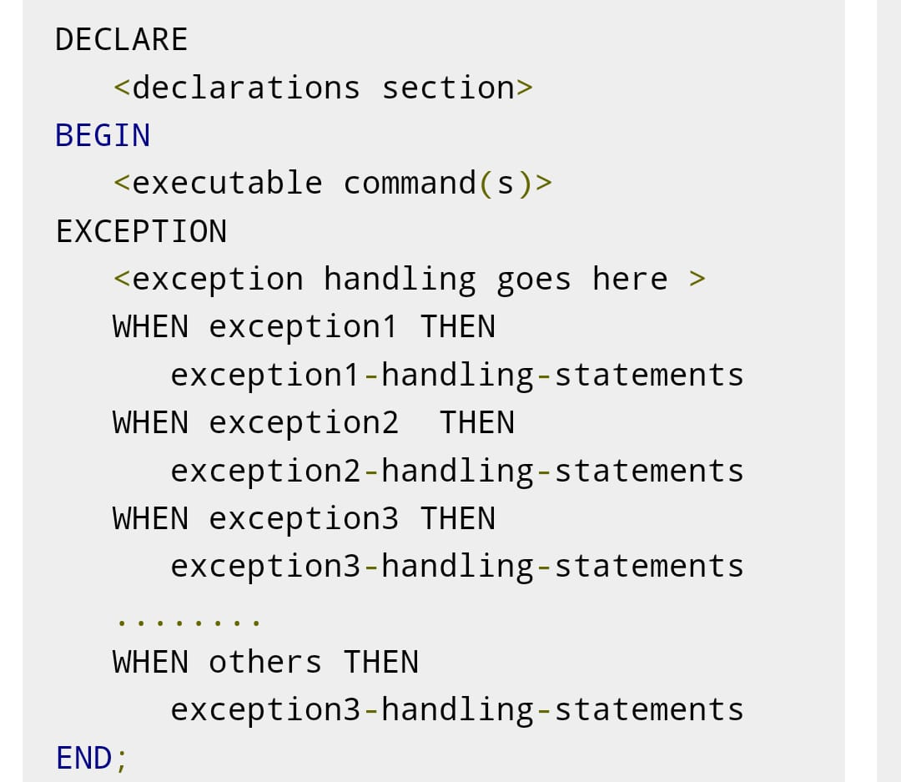

# Topic :- Core Java

Que. 1- Define Java Programming Language?

Ans:

Introduction to Java programming

JAVA was developed by Sun Microsystems Inc in 1991, later acquired by Oracle Corporation. It was developed by James Gosling and Patrick Naughton. It is a simple programming language. Writing, compiling and debugging a program is easy in java. It helps to create modular programs and reusable code.

Java terminology

Before we start learning Java, lets get familiar with common java terms.

Java Virtual Machine (JVM)

This is generally referred as JVM. Before, we discuss about JVM lets see the phases of program execution. Phases are as follows: we write the program, then we compile the program and at last we run the program.

Java Development Kit(JDK)

While explaining JVM and bytecode, I have used the term JDK. Let’s discuss about it. As the name suggests this is complete java development kit that includes JRE (Java Runtime Environment), compilers and various tools like JavaDoc, Java debugger etc.

In order to create, compile and run Java program you would need JDK installed on your computer.

Java Runtime Environment(JRE)

JRE is a part of JDK which means that JDK includes JRE. When you have JRE installed on your system, you can run a java program however you won’t be able to compile it. JRE includes JVM, browser plugins and applets support. When you only need to run a java program on your computer, you would only need JRE.

Java is a platform independent language

Compiler(javac) converts source code (.java file) to the byte code(.class file). As mentioned above, JVM executes the bytecode produced by compiler. This byte code can run on any platform such as Windows, Linux, Mac OS etc. Which means a program that is compiled on windows can run on Linux and vice-versa. Each operating system has different JVM, however the output they produce after execution of bytecode is same across all operating systems. That is why we call java as platform independent language.

Que. 2- What is OOPs in Java ?

Ans:

The main ideas behind Java’s Object-Oriented Programming, OOP concepts include abstraction, encapsulation, inheritance and polymorphism. Basically, Java OOP concepts let us create working methods and variables, then re-use all or part of them without compromising security. Grasping OOP concepts is key to understanding how Java works.

Java defines OOP concepts as follows:

Abstraction: Using simple things to represent complexity. We all know how to turn the TV on, but we don’t need to know how it works in order to enjoy it. In Java, abstraction means simple things like objects, classes and variables represent more complex underlying code and data. This is important because it lets you avoid repeating the same work multiple times.

Encapsulation: The practice of keeping fields within a class private, then providing access to those fields via public methods. Encapsulation is a protective barrier that keeps the data and code safe within the class itself. We can then reuse objects like code components or variables without allowing open access to the data system-wide.

Inheritance: A special feature of Object-Oriented Programming in Java, Inheritance lets programmers create new classes that share some of the attributes of existing classes. Using Inheritance lets us build on previous work without reinventing the wheel.

Polymorphism: Allows programmers to use the same word in Java to mean different things in different contexts. One form of polymorphism is method overloading. That’s when the code itself implies different meanings. The other form is method overriding. That’s when the values of the supplied variables imply different meanings. Let’s delve a little further.

Que. 3- What is Java API ?

Ans:

An application programming interface (API), in the context of Java, is a collection of prewritten packages, classes, and interfaces with their respective methods, fields and constructors. Similar to a user interface, which facilitates interaction between humans and computers, an API serves as a software program interface facilitating interaction.

In Java, most basic programming tasks are performed by the API’s classes and packages, which are helpful in minimizing the number of lines written within pieces of code.

Java Development Kit (JDK) is comprised of three basic components, as follows:

Java compiler

Java Virtual Machine (JVM)

Java Application Programming Interface (API).

Que. 4- What Is Functional Programming?

Ans. -

Basically, functional programming is a style of writing computer programs that treat computations as evaluating mathematical functions.

In mathematics, a function is an expression that relates an input set to an output set.

Importantly, the output of a function depends only on its input. More interestingly, we can compose two or more functions together to get a new function.

LambdaCalculus :

To understand why these definitions and properties of mathematical functions are important in programming, we'll have to go back in time a bit.

In the 1930s, mathematician Alonzo Church developed a formal system to express computations based on function abstraction. This universal model of computation came to be known as lambda calculus.

The Java API, included with the JDK, describes the function of each of its components. In Java programming, many of these components are pre-created and commonly used. Thus, the programmer is able to apply prewritten code via the Java API. After referring to the available API classes and packages, the programmer easily invokes the necessary code classes and packages for implementation.

Que. 5- What is a Java Collection Framework?

Ans. -

A Java collection framework provides an architecture to store and manipulate a group of objects. A Java collection framework includes the following:

Interfaces

Classes

Algorithm

Let’s learn about them in detail:

Interfaces:

Interface in Java refers to the abstract data types. They allow Java collections to be manipulated independently from the details of their representation. Also, they form a hierarchy in object-oriented programming languages.

Classes:

Classes in Java are the implementation of the collection interface. It basically refers to the data structures that are used again and again.

Algorithm:

Algorithm refers to the methods which are used to perform operations such as searching and sorting, on objects that implement collection interfaces. Algorithms are polymorphic in nature as the same method can be used to take many forms or you can say perform different implementations of the Java collection interface.

The Java collection framework provides the developers to access prepackaged data structures as well as algorithms to manipulate data. Next, let us move to the Java collections framework hierarchy and see where these interfaces and classes reside.

List :

A List is an ordered Collection of elements which may contain duplicates. It is an interface that extends the Collection interface. Lists are further classified into the following:

ArrayList

LinkedList

Vectors

Let’s go into detail on each one of them:

Array list:

ArrayList is the implementation of List Interface where the elements can be dynamically added or removed from the list. Also, the size of the list is increased dynamically if the elements are added more than the initial size.

Syntax:

ArrayList object = new ArrayList ();

Linked List:

Linked List is a sequence of links which contains items. Each link contains a connection to another link.

Syntax: Linkedlist object = new Linkedlist();

Java Linked List class uses two types of Linked list to store the elements:

Singly Linked List

Doubly Linked List

Singly Linked List:

In a singly Linked list, each node in this list stores the data of the node and a pointer or reference to the next node in the list. Refer to the below image to get a better understanding of single Linked list.

Doubly Linked List:

In a doubly Linked list, it has two references, one to the next node and another to the previous node. You can refer to the below image to get a better understanding of doubly linked list.

Vectors :

Vectors are similar to arrays, where the elements of the vector object can be accessed via an index into the vector. Vector implements a dynamic array. Also, the vector is not limited to a specific size, it can shrink or grow automatically whenever required. It is similar to ArrayList, but with two differences :

Vector is synchronized.

Vector contains many legacy methods that are not part of the collections framework.

Syntax:

Vector object = new Vector(size,increment);

Queue :

Queue in Java follows a FIFO approach i.e. it orders the elements in First In First Out manner. In a queue, the first element is removed first and last element is removed in the end. Each basic method exists in two forms: one throws an exception if the operation fails, the other returns a special value.

# Topic – JDBC

Que.1- What is JDBC in Java

Ans:JDBC is an application programming interface (API) included in the Java™ platform that enables Java programs to connect to a wide range of databases.

JDBC stands for Java Database Connectivity, which is a standard Java API for database-independent connectivity between the Java programming language and a wide range of databases.

The JDBC library includes APIs for each of the tasks mentioned below that are commonly associated with database usage.

# Topic - Basics of JEE

Que. 1- What is JEE in Java ?

Ans: The Java EE stands for Java Enterprise Edition, which was earlier known as J2EE and is currently known as Jakarta EE. It is a set of specifications wrapping around Java SE (Standard Edition). The Java EE provides a platform for developers with enterprise features such as distributed computing and web services. Java EE applications are usually run on reference run times such as microservers or application servers. Examples of some contexts where Java EE is used are e-commerce, accounting, banking information systems.

Que. 2- What is JSP in Java ?

Ans: Java Server Pages (JSP) is a server-side programming technology that enables the creation of dynamic, platform-independent method for building Web-based applications. JSP have access to the entire family of Java APIs, including the JDBC API to access enterprise databases. This tutorial will teach you how to use Java Server Pages to develop your web applications in simple and easy steps.

JavaServer Pages often serve the same purpose as programs implemented using the Common Gateway Interface (CGI). But JSP offers several advantages in comparison with the CGI.

Performance is significantly better because JSP allows embedding Dynamic Elements in HTML Pages itself instead of having separate CGI files.

Que. 3- What is JSTL in Java?

Ans: The JavaServer Pages Standard Tag Library (JSTL) is a collection of useful JSP tags which encapsulates the core functionality common to many JSP applications.

JSTL has support for common, structural tasks such as iteration and conditionals, tags for manipulating XML documents, internationalization tags, and SQL tags. It also provides a framework for integrating the existing custom tags with the JSTL tags.

Install JSTL Library :

To begin working with JSP pages you need to first install the JSTL library. If you are using the Apache Tomcat container, then follow these two steps −

Step 1 − Download the binary distribution from Apache Standard Taglib and unpack the compressed file.

Step 2 − To use the Standard Taglib from its Jakarta Taglibs distribution, simply copy the JAR files in the distribution's 'lib' directory to your application's webapps\ROOT\WEB-INF\lib directory.

To use any of the libraries, you must include a <taglib> directive at the top of each JSP that uses the library.

Que. 4- What is Servlet in Java ?

Ans: Java Servlets are programs that run on a Web or Application server and act as a middle layer between a requests coming from a Web browser or other HTTP client and databases or applications on the HTTP server.

Using Servlets, you can collect input from users through web page forms, present records from a database or another source, and create web pages dynamically.

Java Servlets often serve the same purpose as programs implemented using the Common Gateway Interface (CGI). But Servlets offer several advantages in comparison with the CGI.

Que. 5- What is HttpServlet in Java ?

Ans: HttpServlet class

The HttpServlet class extends the GenericServlet class and implements Serializable interface. It provides http specific methods such as doGet, doPost, doHead, doTrace etc.

Methods of HttpServlet class

There are many methods in HttpServlet class. They are as follows:

1. public void service(ServletRequestreq,ServletResponse res) dispatches the request to the protected service method by converting the request and response object into http type.

2. protected void service(HttpServletRequest req, HttpServletResponse res) receives the request from the service method, and dispatches the request to the doXXX() method depending on the incoming http request type.

# Topic : HTML5

Que. 1 - what do you mean by HTML5?

Ans: Hypertext Markup Language revision 5 (HTML5) is markup language for the structure and presentation of World Wide Web contents. HTML5 supports the traditional HTML and XHTML-style syntax and other new features in its markup, New APIs, XHTML and error handling.

Que. 2 - How to build a web page using HTML5?

Ans: With your editor open, you can copy and paste the following HTML5 code into a new HTML page.

<!DOCTYPE html>

<html>

<head>

<title>Your web page title</title>

</head>

<body>

The content you want to display to users.

</body>

</html>

# Topic : CSS

Que. 1:-Wap for adding image in CSS?

Ans :

section {

background-image: url("images/sunset.png");

}

Que. 2 - wap to make your page responsive.

Ans :

<meta name="viewport" content="width=device-width, initial-scale=1.0">

Que. 3 - Define css techniques with bootstrap.

Ans: Here's how the Bootstrap grid system works: Rows must be placed within a .container (fixed-width) or .container-fluid (full-width) for proper alignment and padding. Use rows to create horizontal groups of columns. Content should be placed within columns, and only columns may be immediate children of rows.

Que. 4 - Create layout using CSS and bootstrap.

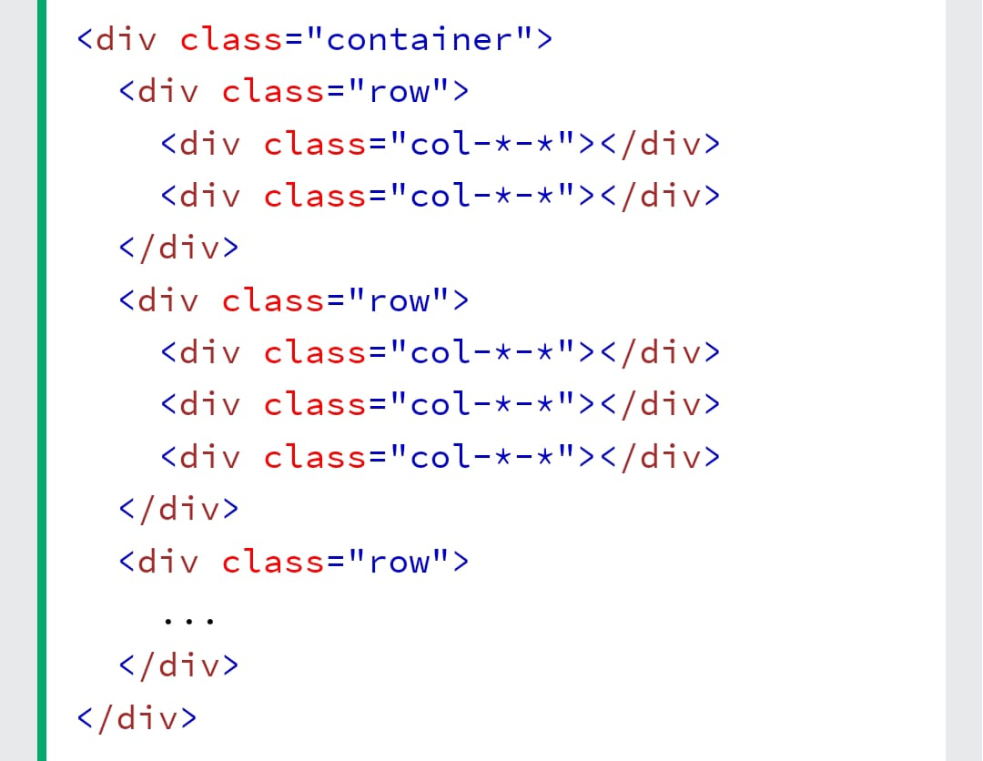

# Topic : JavaScript and jQuery

Que. 1- what is JavaScript?

Ans: JavaScript is a scripting or programming language that allows you to implement complex features on web pages — every time a web page does more than just sit there and display static information for you to look at — displaying timely content updates, interactive maps, animated 2D/3D graphics, scrolling video jukeboxes, etc. — you can bet that JavaScript is probably involved. It is the third layer of the layer cake of standard web technologies, two of which (HTML and CSS) we have covered in much more detail in other parts of the Learning Area.

Que. 2- what is jQuery?

Ans: jQuery is a lightweight, "write less, do more", JavaScript library. The purpose of jQuery is to make it much easier to use JavaScript on your website.

Que. 3 - What is Ajax ?

Ans: Ajax is a set of web development techniques that uses various web technologies on the client-side to create asynchronous web applications. With Ajax, web applications can send and retrieve data from a server asynchronously without interfering with the display and behaviour of the existing page.